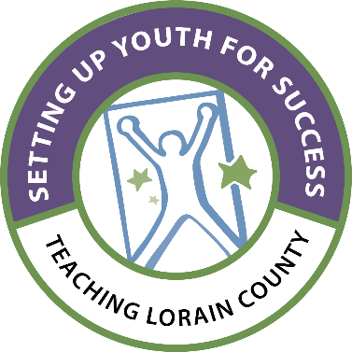

**Setting Up Youth for Success - Teaching Lorain County**

Tentative Class of 2024

*Schedule of Classes and Events for the 2023-2024 Class Year

|  |  |  |
| --- | --- | --- |
| Date | Times |  |
| Wednesday, November 1st, 2023 | All Day | LLC Session Day |
| Wednesday, December 6th, 2023 | All Day | LLC Session Day |
| Wednesday, January 10th, 2024 | All Day | LLC Session Day |
| Wednesday, February 7th, 2024 | All Day | LLC Session Day |
| Wednesday, March 6th, 2024 | All Day | LLC Session Day |
| Wednesday, April 24th, 2024 | All Day | LLC Session Day & Recognition Ceremony |

*Please Mark Your Calendars for These Dates.