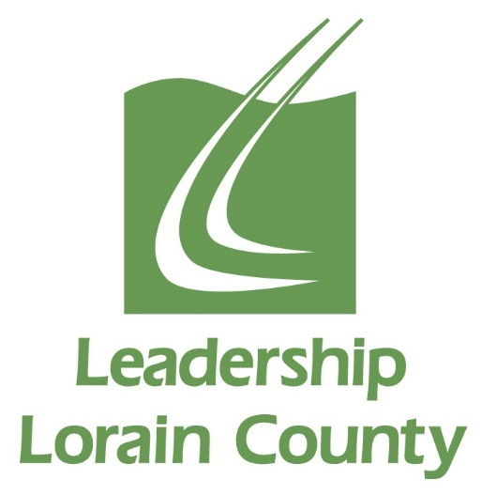

Leadership Lorain County
Tentative Class of 2024
*Schedule of Classes and Events for the 2023-2024 Class Year
Date | Times
Wednesday, September 20th, 2023 | All Day | LLC Session Day
Thursday & Friday, October 19th & 20th, 2023 | 8am 9/19  to 5pm 9/20 | Overnight Retreat
Wednesday, November 15th, 2023 | All Day | LLC Session Day
Wednesday, December 13th, 2023 | All Day | LLC Session Day
Wednesday, January 17th, 2024 | All Day | Mid-Year Retreat
Wednesday, February 21st, 2024 | All Day | LLC Session Day
Wednesday, March 20th, 2024 | All Day | LLC Session Day
Wednesday, April 17th, 2024 | All Day | LLC Session Day
Wednesday, May 1st, 2024 | All Day | LLC Session Day
Wednesday, May 15th, 2024 | Morning & Evening | Closing Retreat in am, Induction Ceremony in pm
May/June 2024 | TBD in  January | Participation in one Alumni Hosted event. Examples are: Strides for Leadership 5k and Connecting for Kids Resource Fair

*Please Mark Your Calendars For These Dates.

