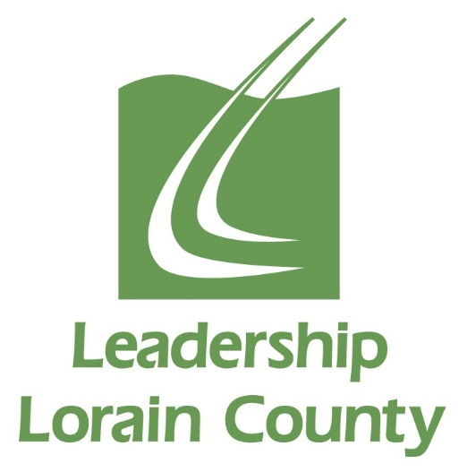

Leadership Lorain County
Class of 2023
*Schedule of Classes and Events for the 2022-2023 Class Year
Date | Times
Wednesday, September 21st, 2022 | All Day | LLC Session Day
Wednesday and Thursday, October 19th & 20th, 2022 | 8am 9/19  to 5pm 9/20 | Overnight Retreat
Wednesday, November 16th, 2022 | All Day | LLC Session Day
Wednesday, December 14th, 2022 | All Day | LLC Session Day
Wednesday, January 18th, 2023 | All Day | Mid-Year Retreat
Wednesday, February 15th, 2023 | All Day | LLC Session Day
Wednesday, March 15th, 2023 | All Day | LLC Session Day
Wednesday, April 19th, 2023 | All Day | LLC Session Day
Wednesday, May 3rd, 2023 | All Day | LLC Session Day
Wednesday, May 17th, 2023 | Morning & Evening | Closing Retreat in am, Induction Ceremony in pm
May/June 2023 | TBD in  January | Participation in one Alumni Hosted event. Examples are: Strides for Leadership 5k and Connecting for Kids Resource Fair

*Please Mark Your Calendars For These Dates.

