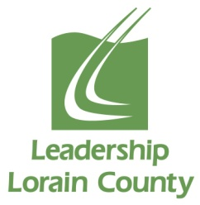
BEST CLASS OF 2022 PROJECT PROPOSAL
Your Name: Phone:
Email:
1. Your recommendation for the Class of 2022 project:

2. Anticipated timeframe to complete the project (all projects should be completed between January and May of
2022)

3. Beneficiaries of the project?

4. Will funding be required? Yes No If yes, who would fund the project?

5. Who may need to collaborate to ensure the success of this project? (Individuals, businesses, etc.)

6. Are there specific skills required to complete this project? Yes No
If yes, please explain:

7. Is this project a one-time undertaking? Yes No
If no, will it require a continuation year after year? Yes No
Please explain:

8. Please identify the contact person at the project location.
Name: Phone:

Organization: Email:

I understand that an employee of the nonprofit agency must be present at all times during any on-site project work. By signing this form, I commit to the Class of 2022 that the agency that I represent will do its part to ensure the success of this project.

______________________________________ ________________________
Signature of Executive Director Date

PLEASE RETURN THIS COMPLETED PROPOSAL FORM TO Leadership Lorain County at llc@leadershiploraincouny.com by January 6th, 2022. Call 440-281-8535 with any questions or concerns.

