CORPORATE CHALLENGE LORAIN COUNTY
Dart Tournament

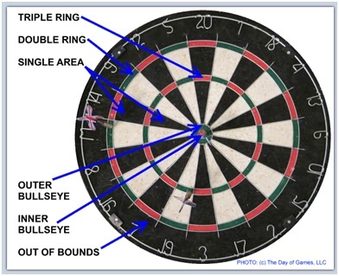
Starting the Game:
Each 2-man team will name will be placed in a bag to select initial team matchups prior to game day. At the start of the game, a coin will be flipped to decide which team will throw first.
Scoring:
Darts that hit the bullseye are worth 50 points, and the outer bullseye is worth 25 points. The open spaces within each sliver of a scoring section are worth the point value assigned around the edge. The inner ring is the “triples” scoring section, and the outer ring is the “doubles” scoring section. All darts that land in either section shall double or triple the applicable assigned score. For example, a dart that lands in the triples ring of the scoring section of 19 shall score a total of 57. Here is how a complete scoring round would work if you started with a score of 701 and three darts were thrown and they landed in triple 20, double 15, and single 8: The total for that round would be 60 (triple 20) + 30 (double 15) +8 (single 8) = 98, then you should subtract 98 from 701 which would be 603.
Finishing:
The team must hit any number that takes their score exactly to zero. You must end with exactly zero if you go below zero your score resets to what it was before the team threw their 3 darts for that round.
The Game will be played on an electronic board that will calculate the score during the game. The tournament will be a double elimination challenge, with a loser’s bracket. The finals will be the 1st place team from round 1 and the 1st place team from the loser’s bracket. If the team from round 1 is undefeated, the challenging team must beat the undefeated team twice to win.

WAIVERS ARE REQUIRED BEFORE THE DAY OF THE EVENT.

