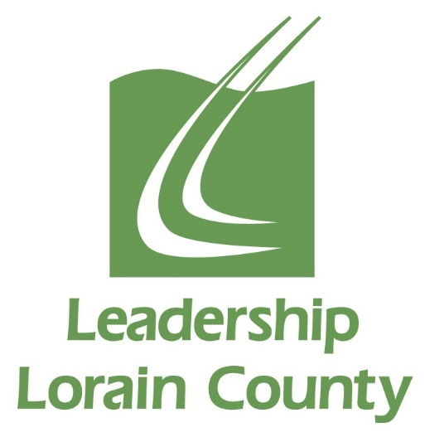

Leadership Lorain County
Class of 2021
*Schedule of Classes and Events for the 2020-2021 Class Year
Date | Times
Wednesday, August 7th, 2019 | All Day | Orientation & Road Rally
Thursday and Friday, September 17th & 18th, 2020 | 8am 9/17  to 5pm 9/18 | Overnight Retreat
Wednesday, October 7th, 2020 | All Day | History & Philanthropy Session Day
Wednesday, November 4th, 2020 | All Day | Social Justice Session Day
Wednesday, December 2nd, 2020 | All Day | Education Session Day
Wednesday, January 8th, 2021 | All Day | Mid-Year Retreat
Wednesday, February 3rd, 2021 | All Day | Law, Government & Politics Session Day
Wednesday, March 3rd, 2021 | All Day | Economic Development Session Day
Wednesday, April 7th, 2021 | All Day | Health & Wellness Session Day
Wednesday, May 5th, 2021 | All Day | Loving Lorain County Day
Wednesday, May 19th, 2021 | Morning & Evening | Closing Retreat in am, Induction Ceremony in pm
May/June 2021 | TBD in  January | Participation in one Alumni Hosted event. Examples are: Strides for Leadership 5k and United Way’s June Day of Action

*Please Mark Your Calendars For These Dates.

