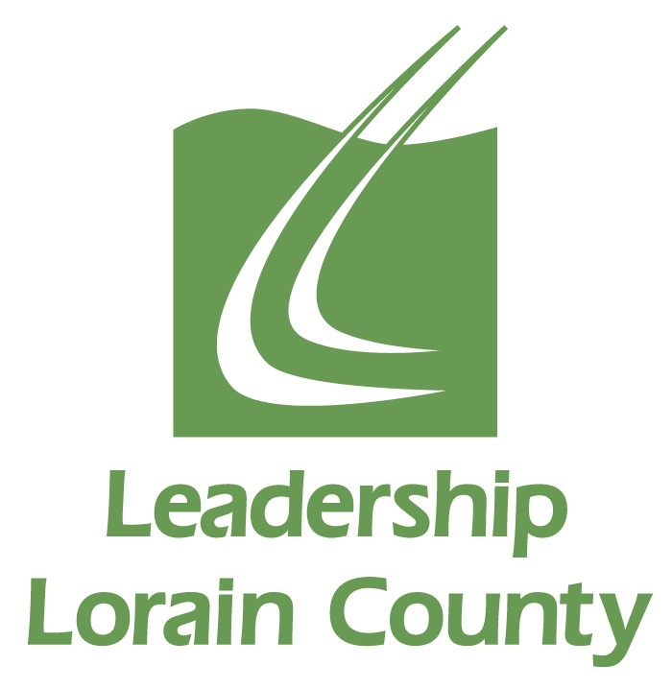

The Class of 2020 will be the 35th class to graduate from Leadership’s Signature Program. Like their predecessors, they wish to make a difference and leave their handprint on Lorain County. We seek your input for projects worthy of pursuit based on the following criteria:
- The period of time to complete the project is from January to Graduation in May, just five months.

- Type of projects- In Leadership Lorain County each class strives to be the best class. This should be reflective in the project or projects that are agreed upon to complete. Non-profit organizations in Lorain County may share a need or want where the class may assist. Collaboration and Innovation within the county is always encouraged.

- Economics- There is to be no project that is exclusively fundraising, and the proposing agency will bear the ultimate responsibility of any project costs. However, the Class of 2020 is welcome to collaborate with other groups who have the ability to seek funds.

- In order for an idea to be considered, a representative of the agency must commit to be on-site and available while any project work is completed.

Using these criteria, please complete the Class of 2020 Project Proposal.

All proposals will be vetted by Leadership staff. Proposals will be submitted to the Class of 2020 for their selection on January 8. All agencies submitting proposals will be notified of the outcome.

Deadline for proposals is Friday, November 22nd. Forward your completed project form to Julie Cruz Blair at julie@leadershiploraincounty.com.

Please call 440-281-8535 with any questions or concerns.

