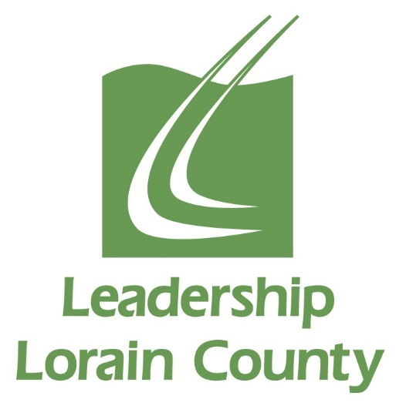

Leadership Lorain County
Class of 2020
*Schedule of Classes and Events for the 2019-2020 Class Year
Date | Times
Wednesday, August 7th, 2019 | All Day | Orientation & Road Rally
Thursday and Friday, September 12th & 13th, 2019 | 8am 9/12  to 5pm 9/13 | Overnight Retreat
Wednesday, October 2nd, 2019 | All Day | History & Philanthropy Session Day
Wednesday, November 6th, 2019 | All Day | Social Justice Session Day
Wednesday, December 4th, 2019 | All Day | Education Session Day
Wednesday, January 8th, 2020 | All Day | Mid-Year Retreat
Wednesday, February 5th, 2020 | All Day | Law, Government & Politics Session Day
Wednesday, March 4th, 2020 | All Day | Economic Development Session Day
Wednesday, April 1st, 2020 | All Day | Health & Wellness Session Day
Wednesday, May 6th, 2020 | All Day | Loving Lorain County Day
Wednesday, May 13th, 2020 | Morning & Evening | Closing Retreat in am, Induction Ceremony in pm
May/June 2020 | TBD in  January | Participation in one Alumni Hosted event. Examples are: Strides for Leadership 5k and United Way’s June Day of Action

*Please Mark Your Calendars For These Dates.

